

**Project Report – Steam Man**

**13006107 Introduction to Computers and Programming**

**Software Engineering Program**

**Faculty of Engineering, KMITL**

By

63011193 Naral Chalermchaikosol



Introduction

Steam Man is a 2D side scroller running game.

You gain points by jumping over obstacles.

Do your best to avoid them, as bumping into them results in game over.

Libraries used:

* **Pygame** – Driver library of the project. This allows for sprite animation, background music and more.
* **random** – Randomize the height of each pipe and each raven.
* **sys** – Allows for pygame application exit.

Motivation / inspiration:

8-bit side scroller games used to dominate the market when I was young, and I was a huge fan of those. Whenever I think of creating a video game, these games come to mind. Creating “Steam Man” not only helped me bring back good memories but also refined my coding skills.

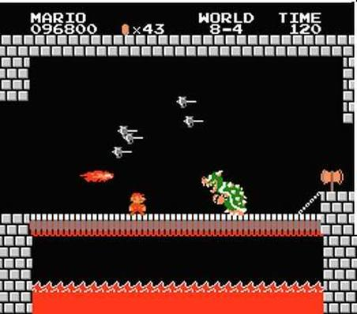 

Screenshots

Starting screen / game over screen

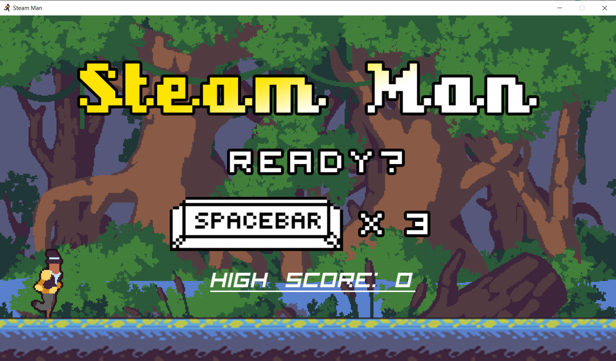

Gameplay Mechanics

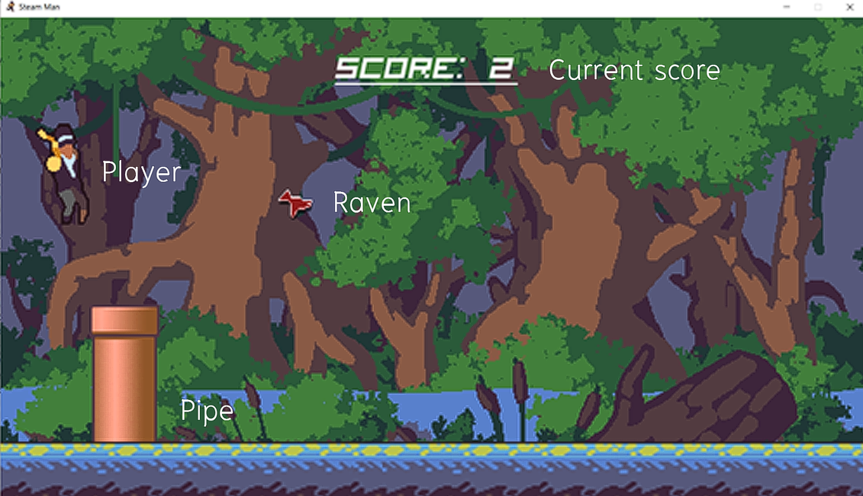

The game features ravens and pipes as obstacles,

bumping into them results in game over.

However, successfully jumping over a pipe grants you a point.

Your character can jump up to three times before needing to land.

Different sceneries with different background music

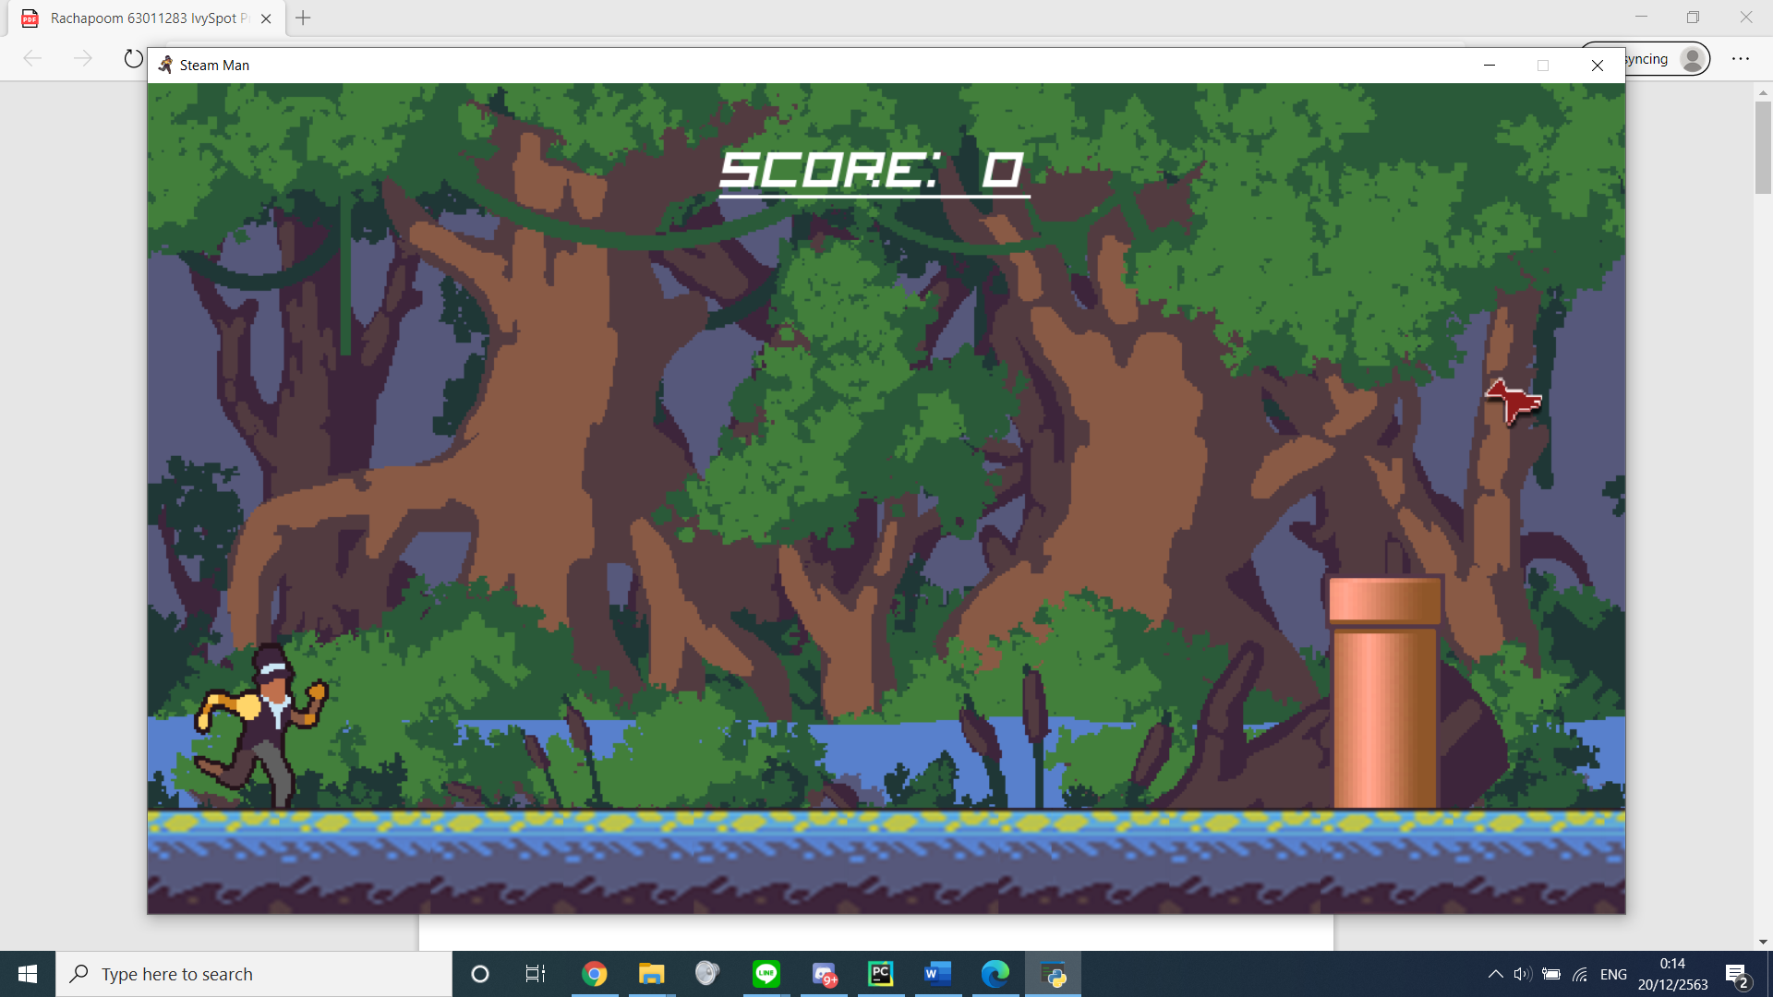

Swamp

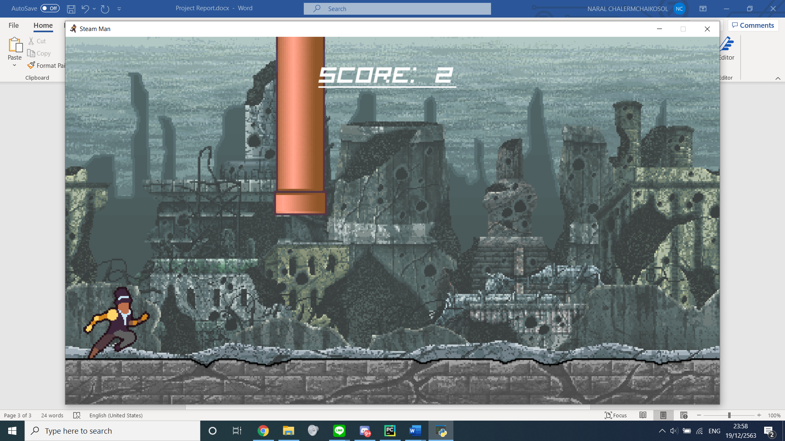

Destroyed City

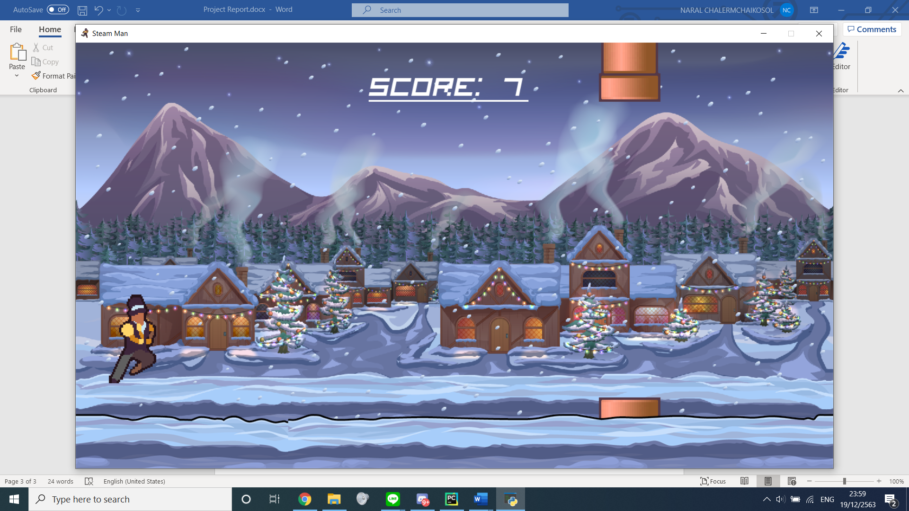

Snow land

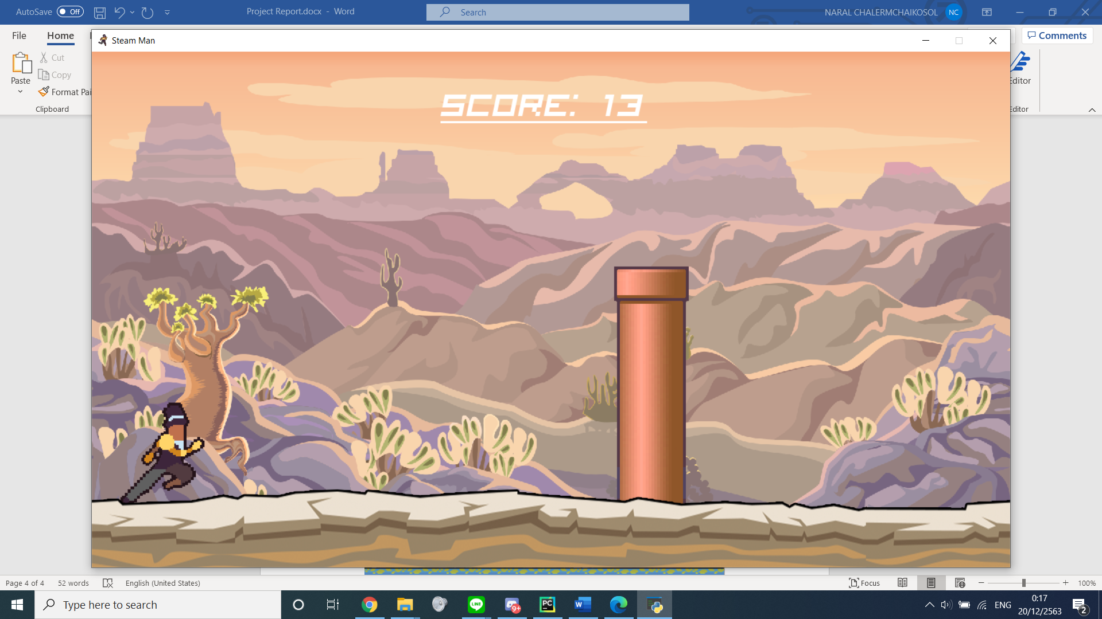

Desert

Source code preview

Note – the .py file is attached to the zip

